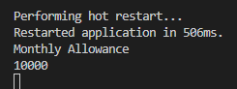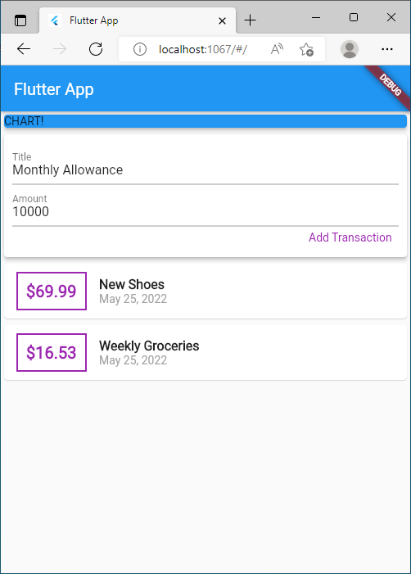

Adding variables to hold user input and events to widgets

What are flutter Controllers?

Controllers are a means to give control to a parent widget over its child state. The main point of selling controllers is that they remove the need of a GlobalKey to access the widget state. This makes it harder to do anti-pattern stuff and increase performances.

What is a TextEditingController?

It is a controller for an editable text field. It can also be used to provide an initial value for a text field. If you build a text field with a controller that already has text, the text field will use that text as its initial value.

What are other types of controllers? Give sample

We can also create custom controllers in flutter.

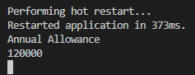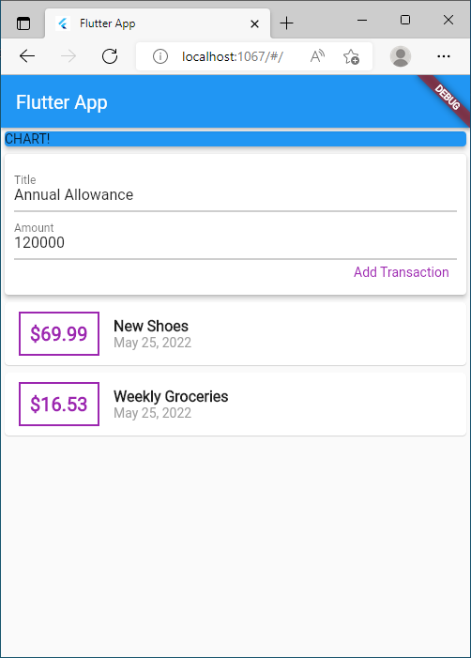

Adding controllers